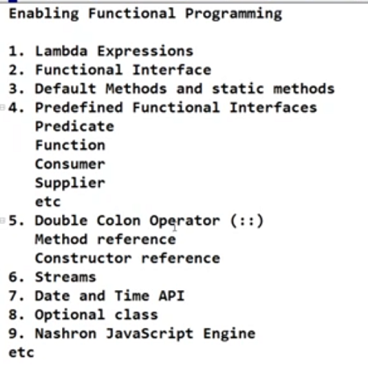

Java 8 enhancement date 18 march 2014

Java 10 sep 2018